Configure a Development Environment

Christine Hodges

Rasmussen College

Author Note

This paper is being submitted on April 6th, 2018 for Professor Darice Corey’s CIS3801 Fundamentals of Mobile Web Application Development Course.

* + Azure VM setup. One snapshot showing the Overview screen is fine.

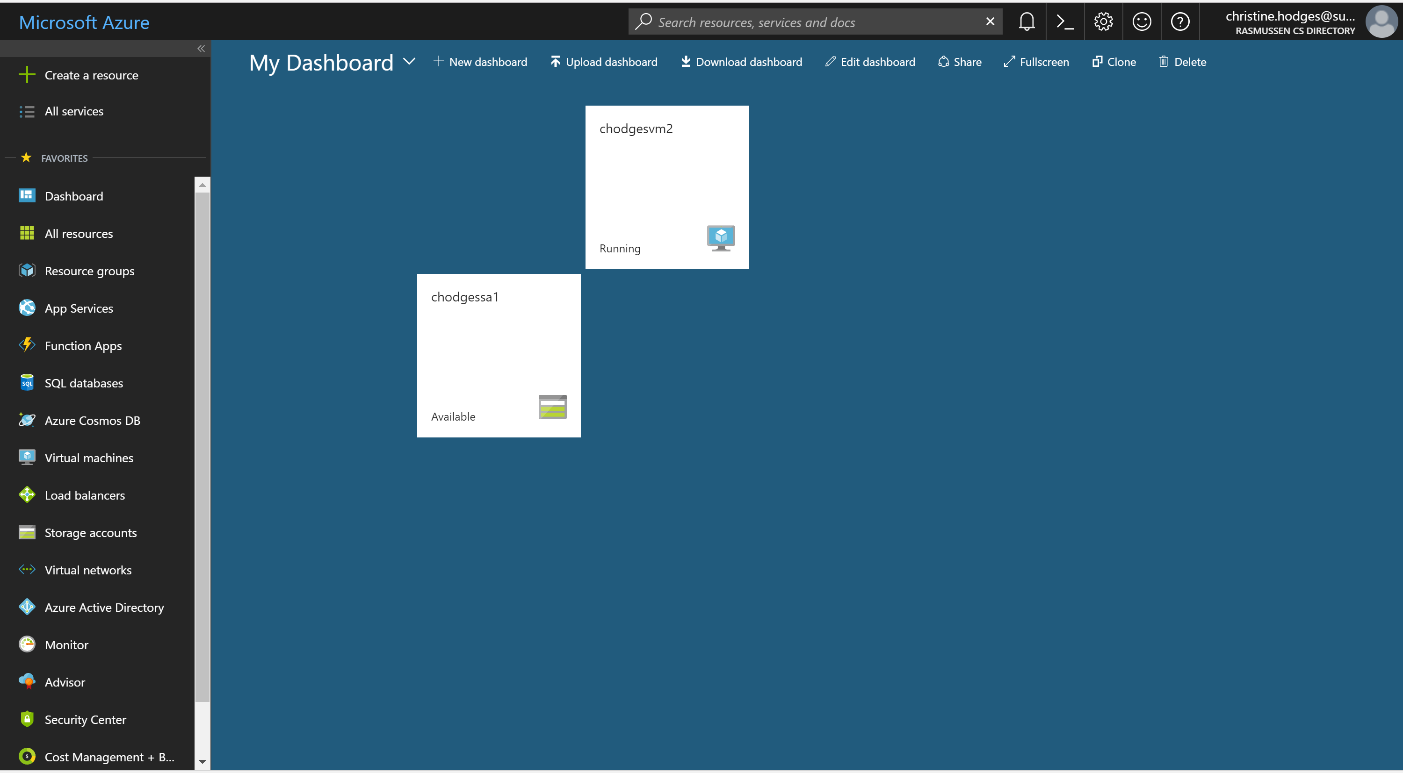

* + Configuring Putty – autologin and localhost

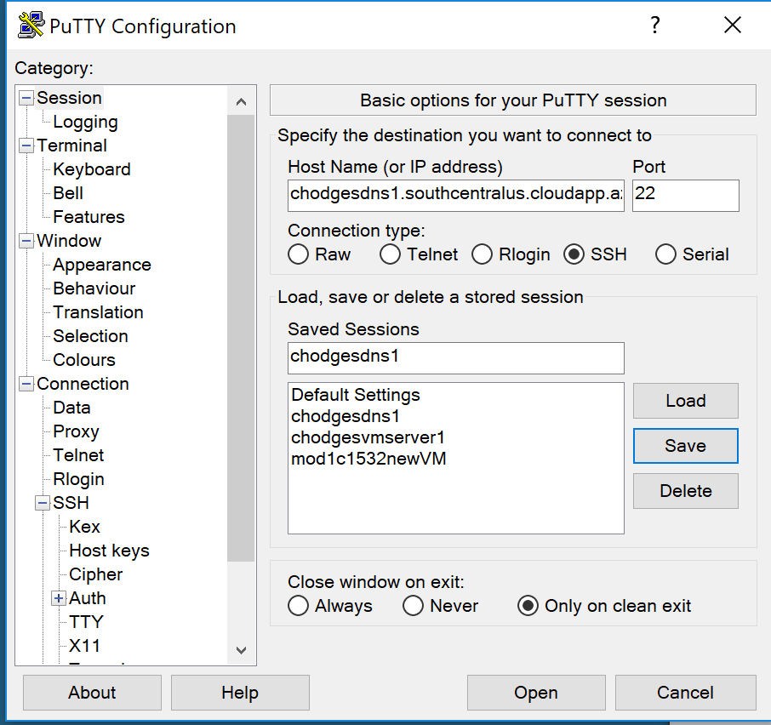

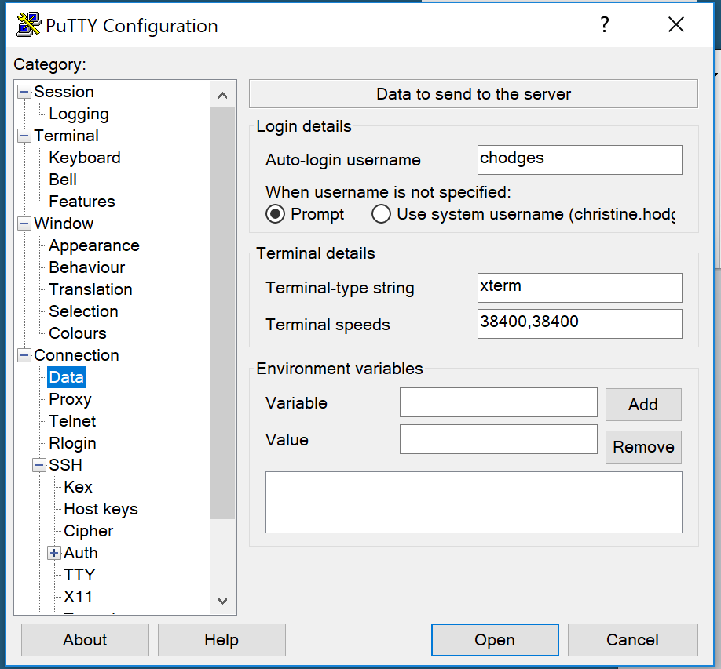

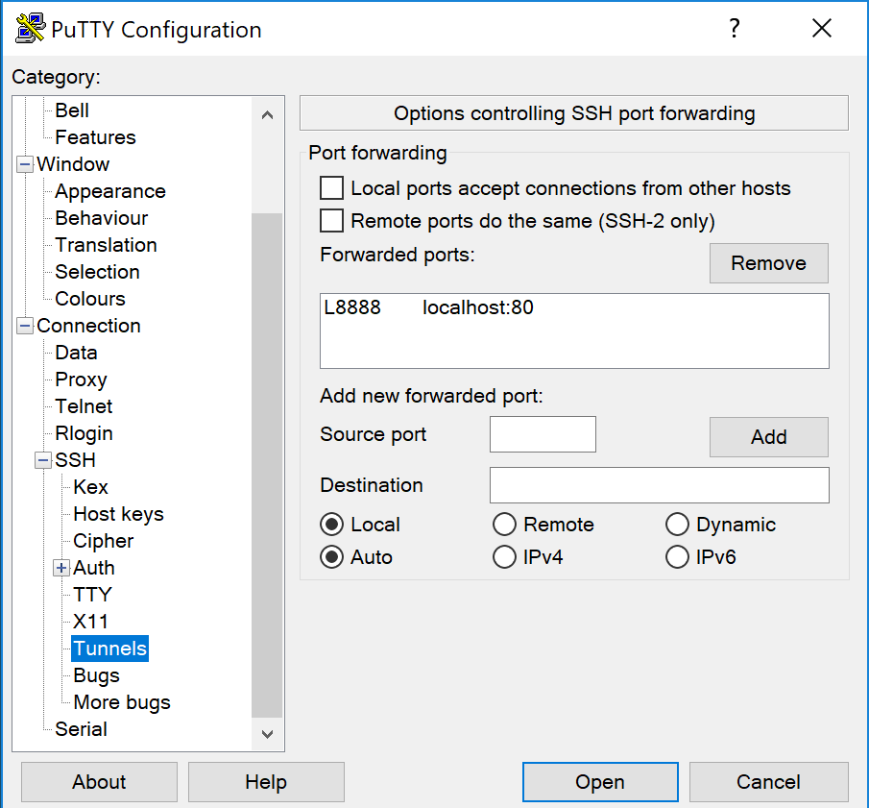

All steps to import the adventureworks db.

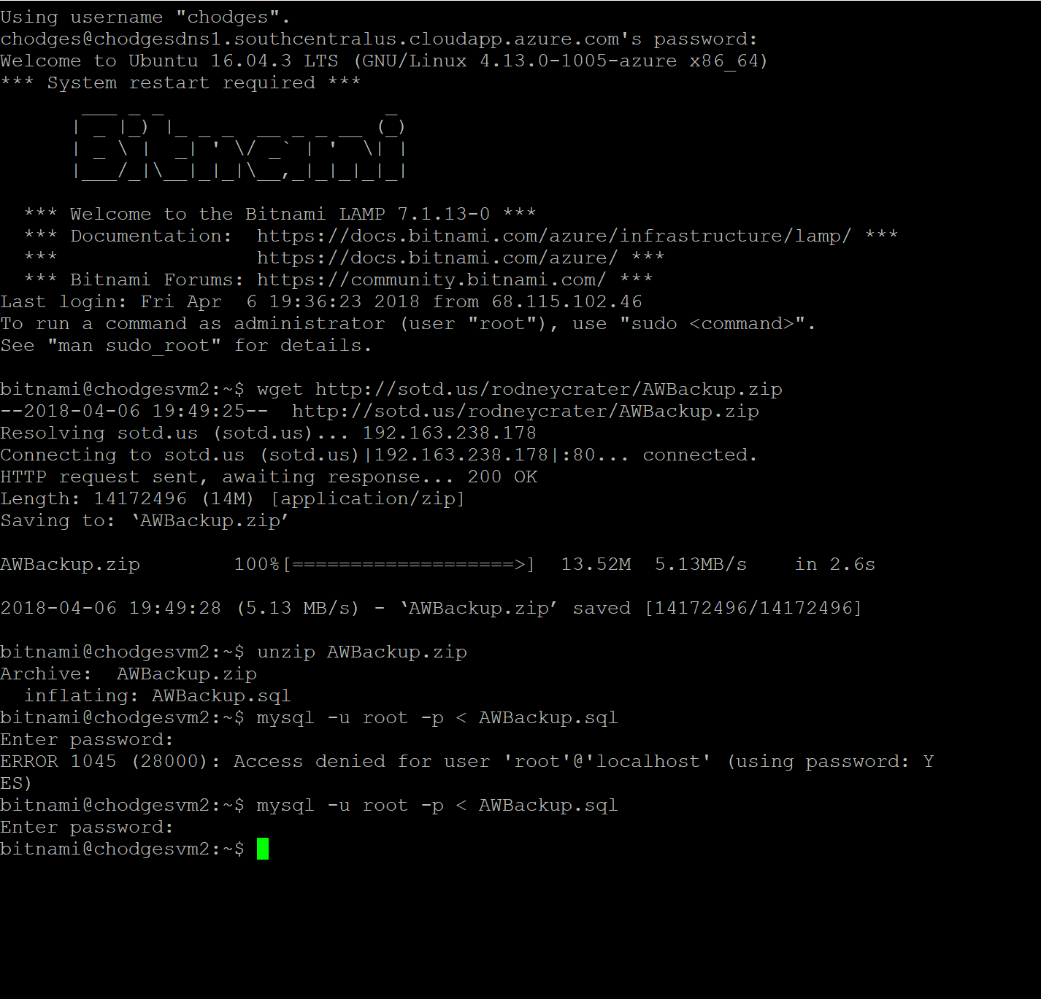

Snapshot of adventureworks in phpMyAdmin by browsing to localhost:8888/phpmyadmin

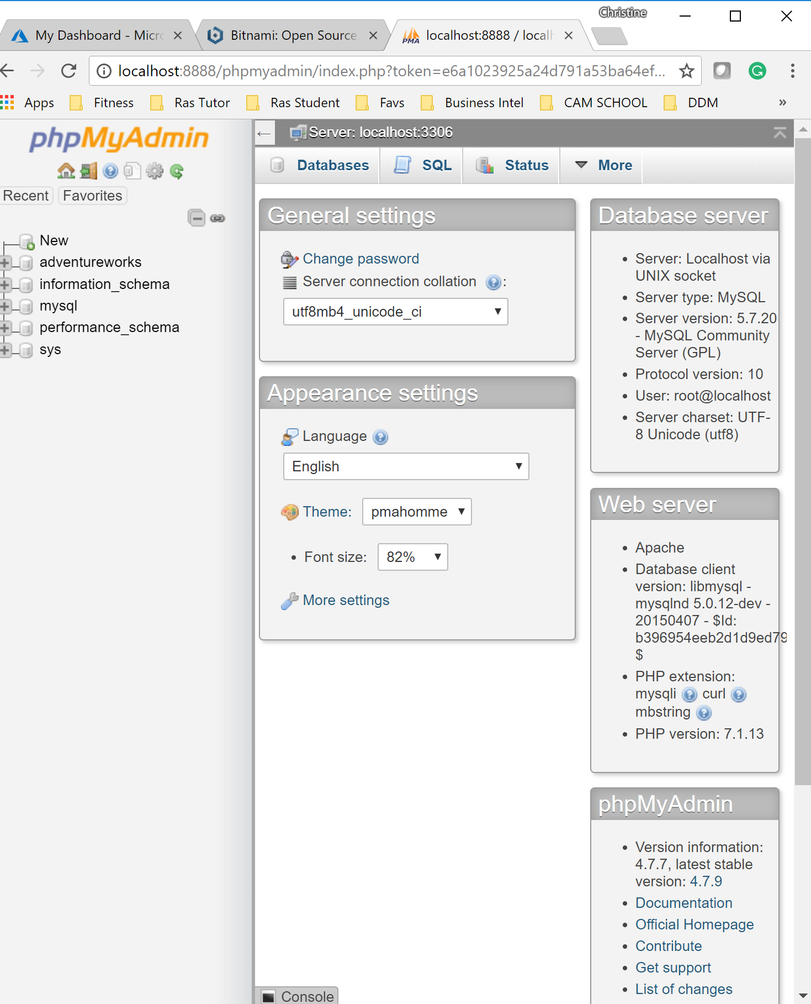

Configuring Filezilla

* + - snapshot of site manager connection

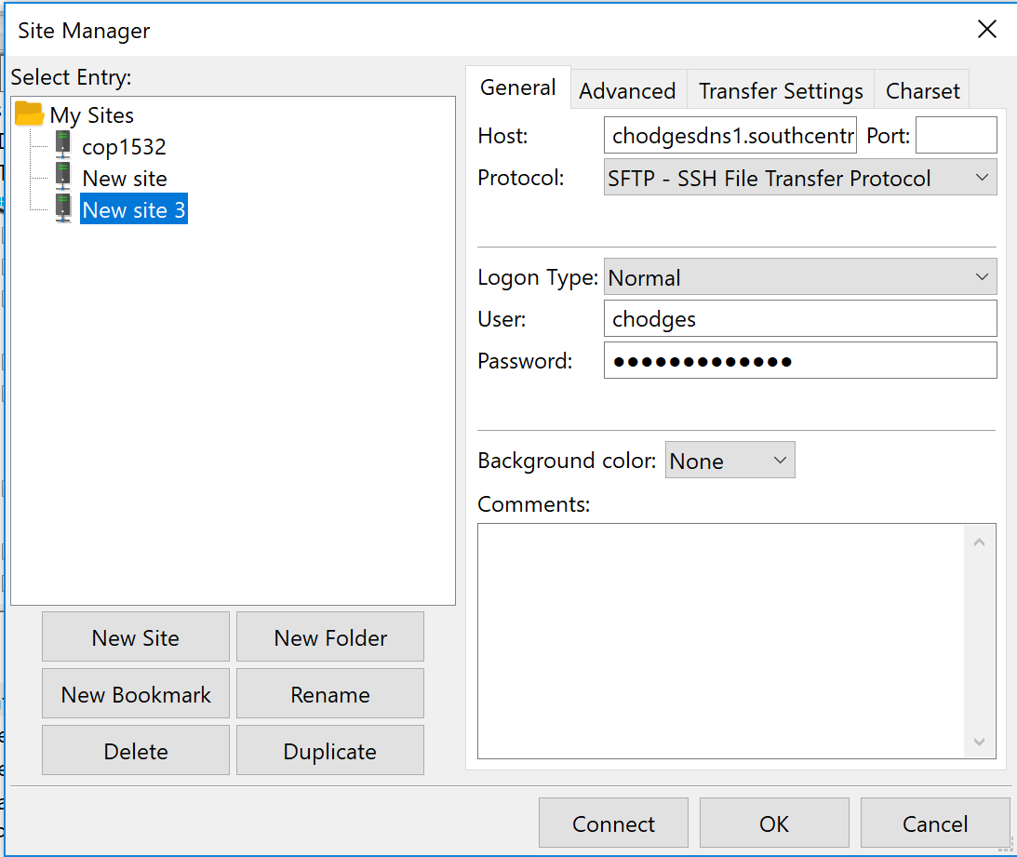

* + - remote site folder list

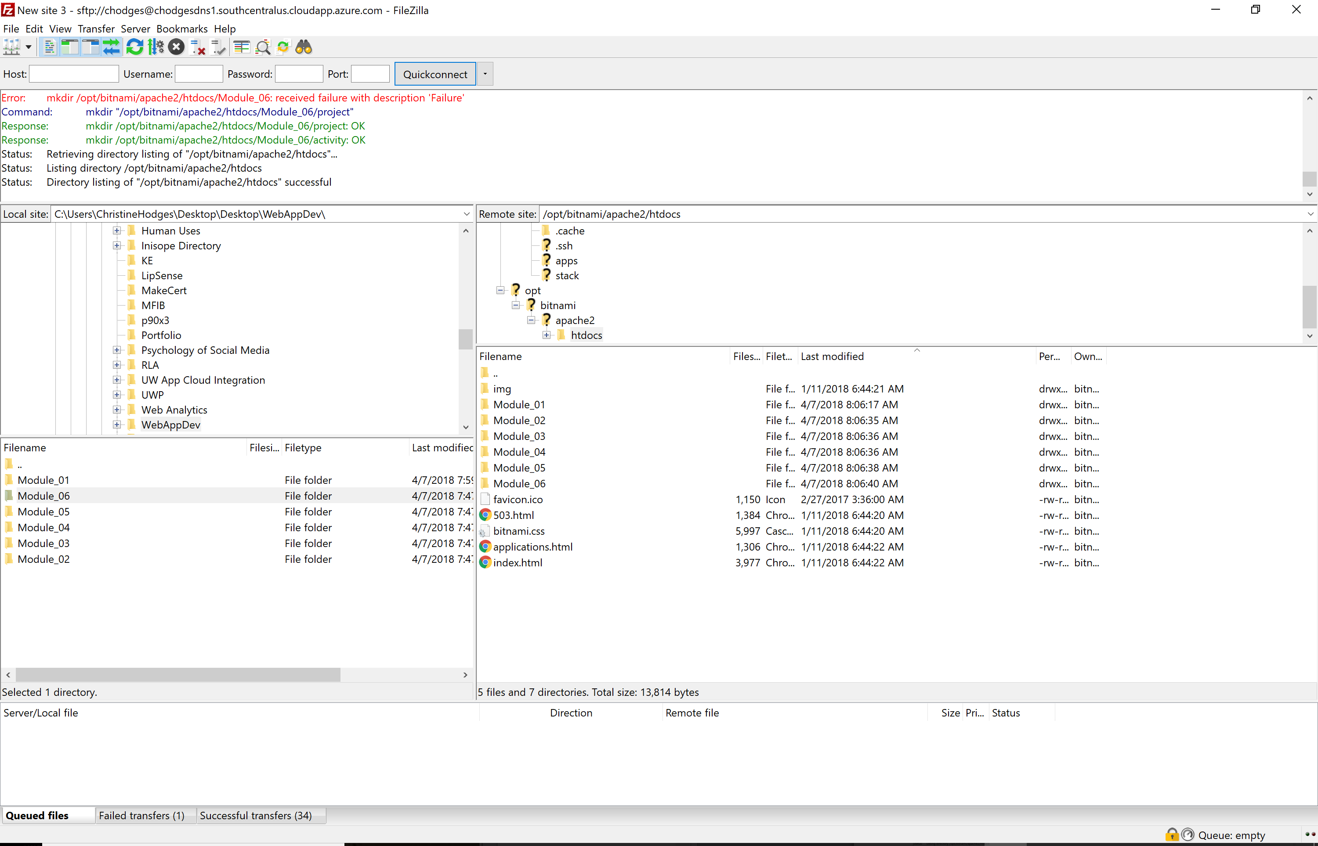

* + - copied files to htdocs folder.

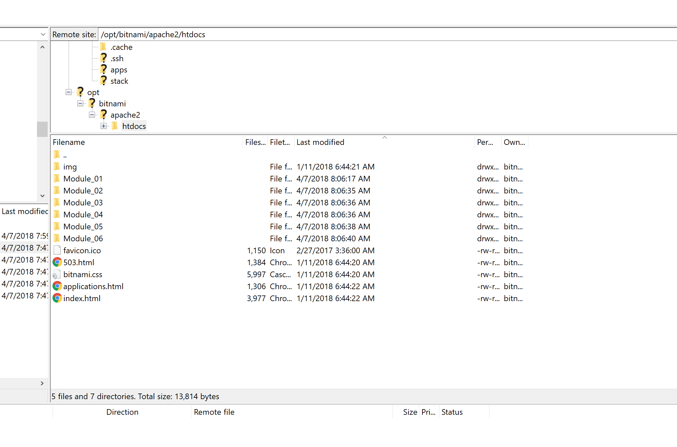

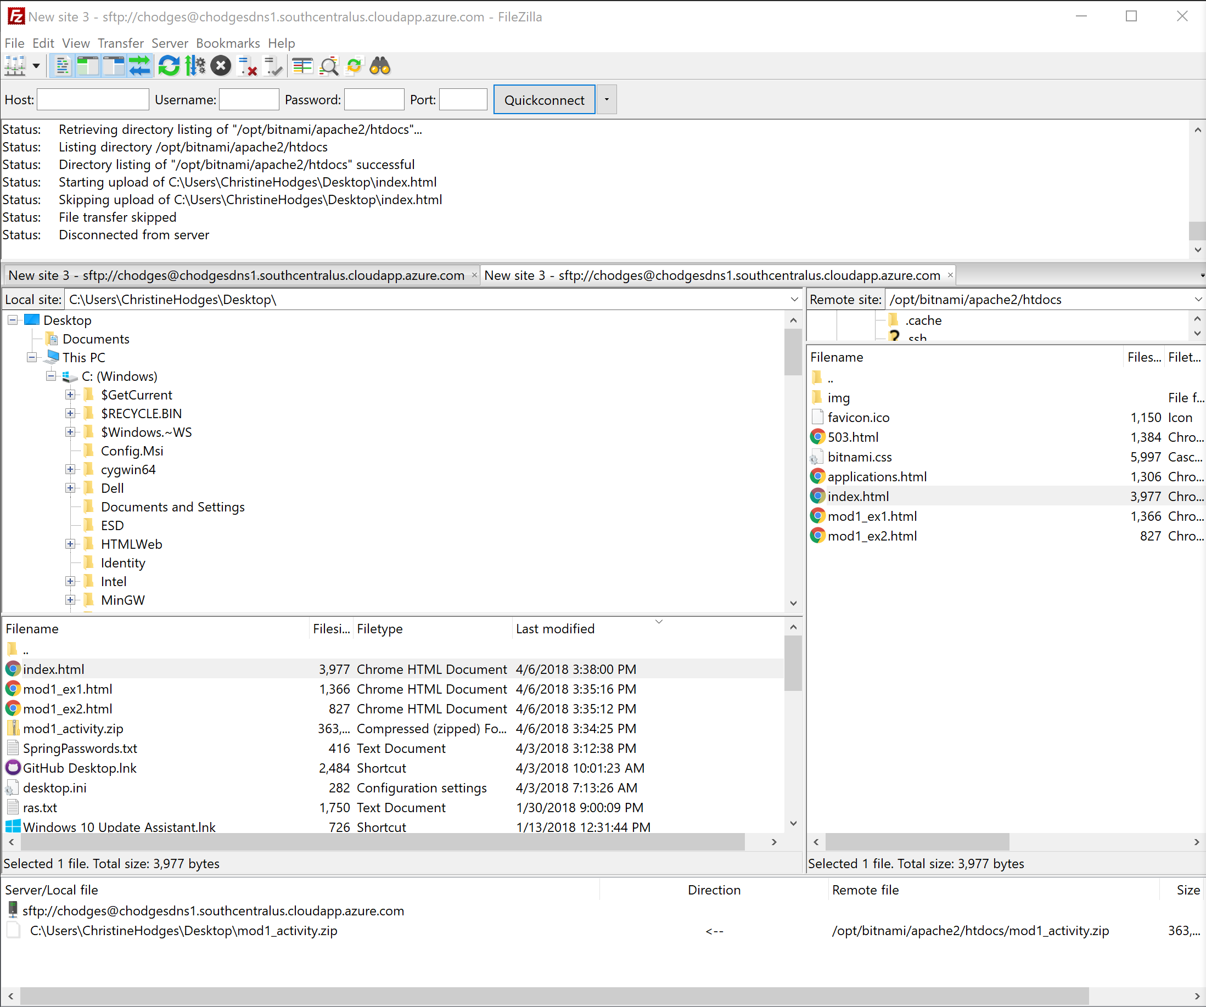

* + Atom – show list of web folders (module 1, module 2, module 3, etc. with activity and project folders.

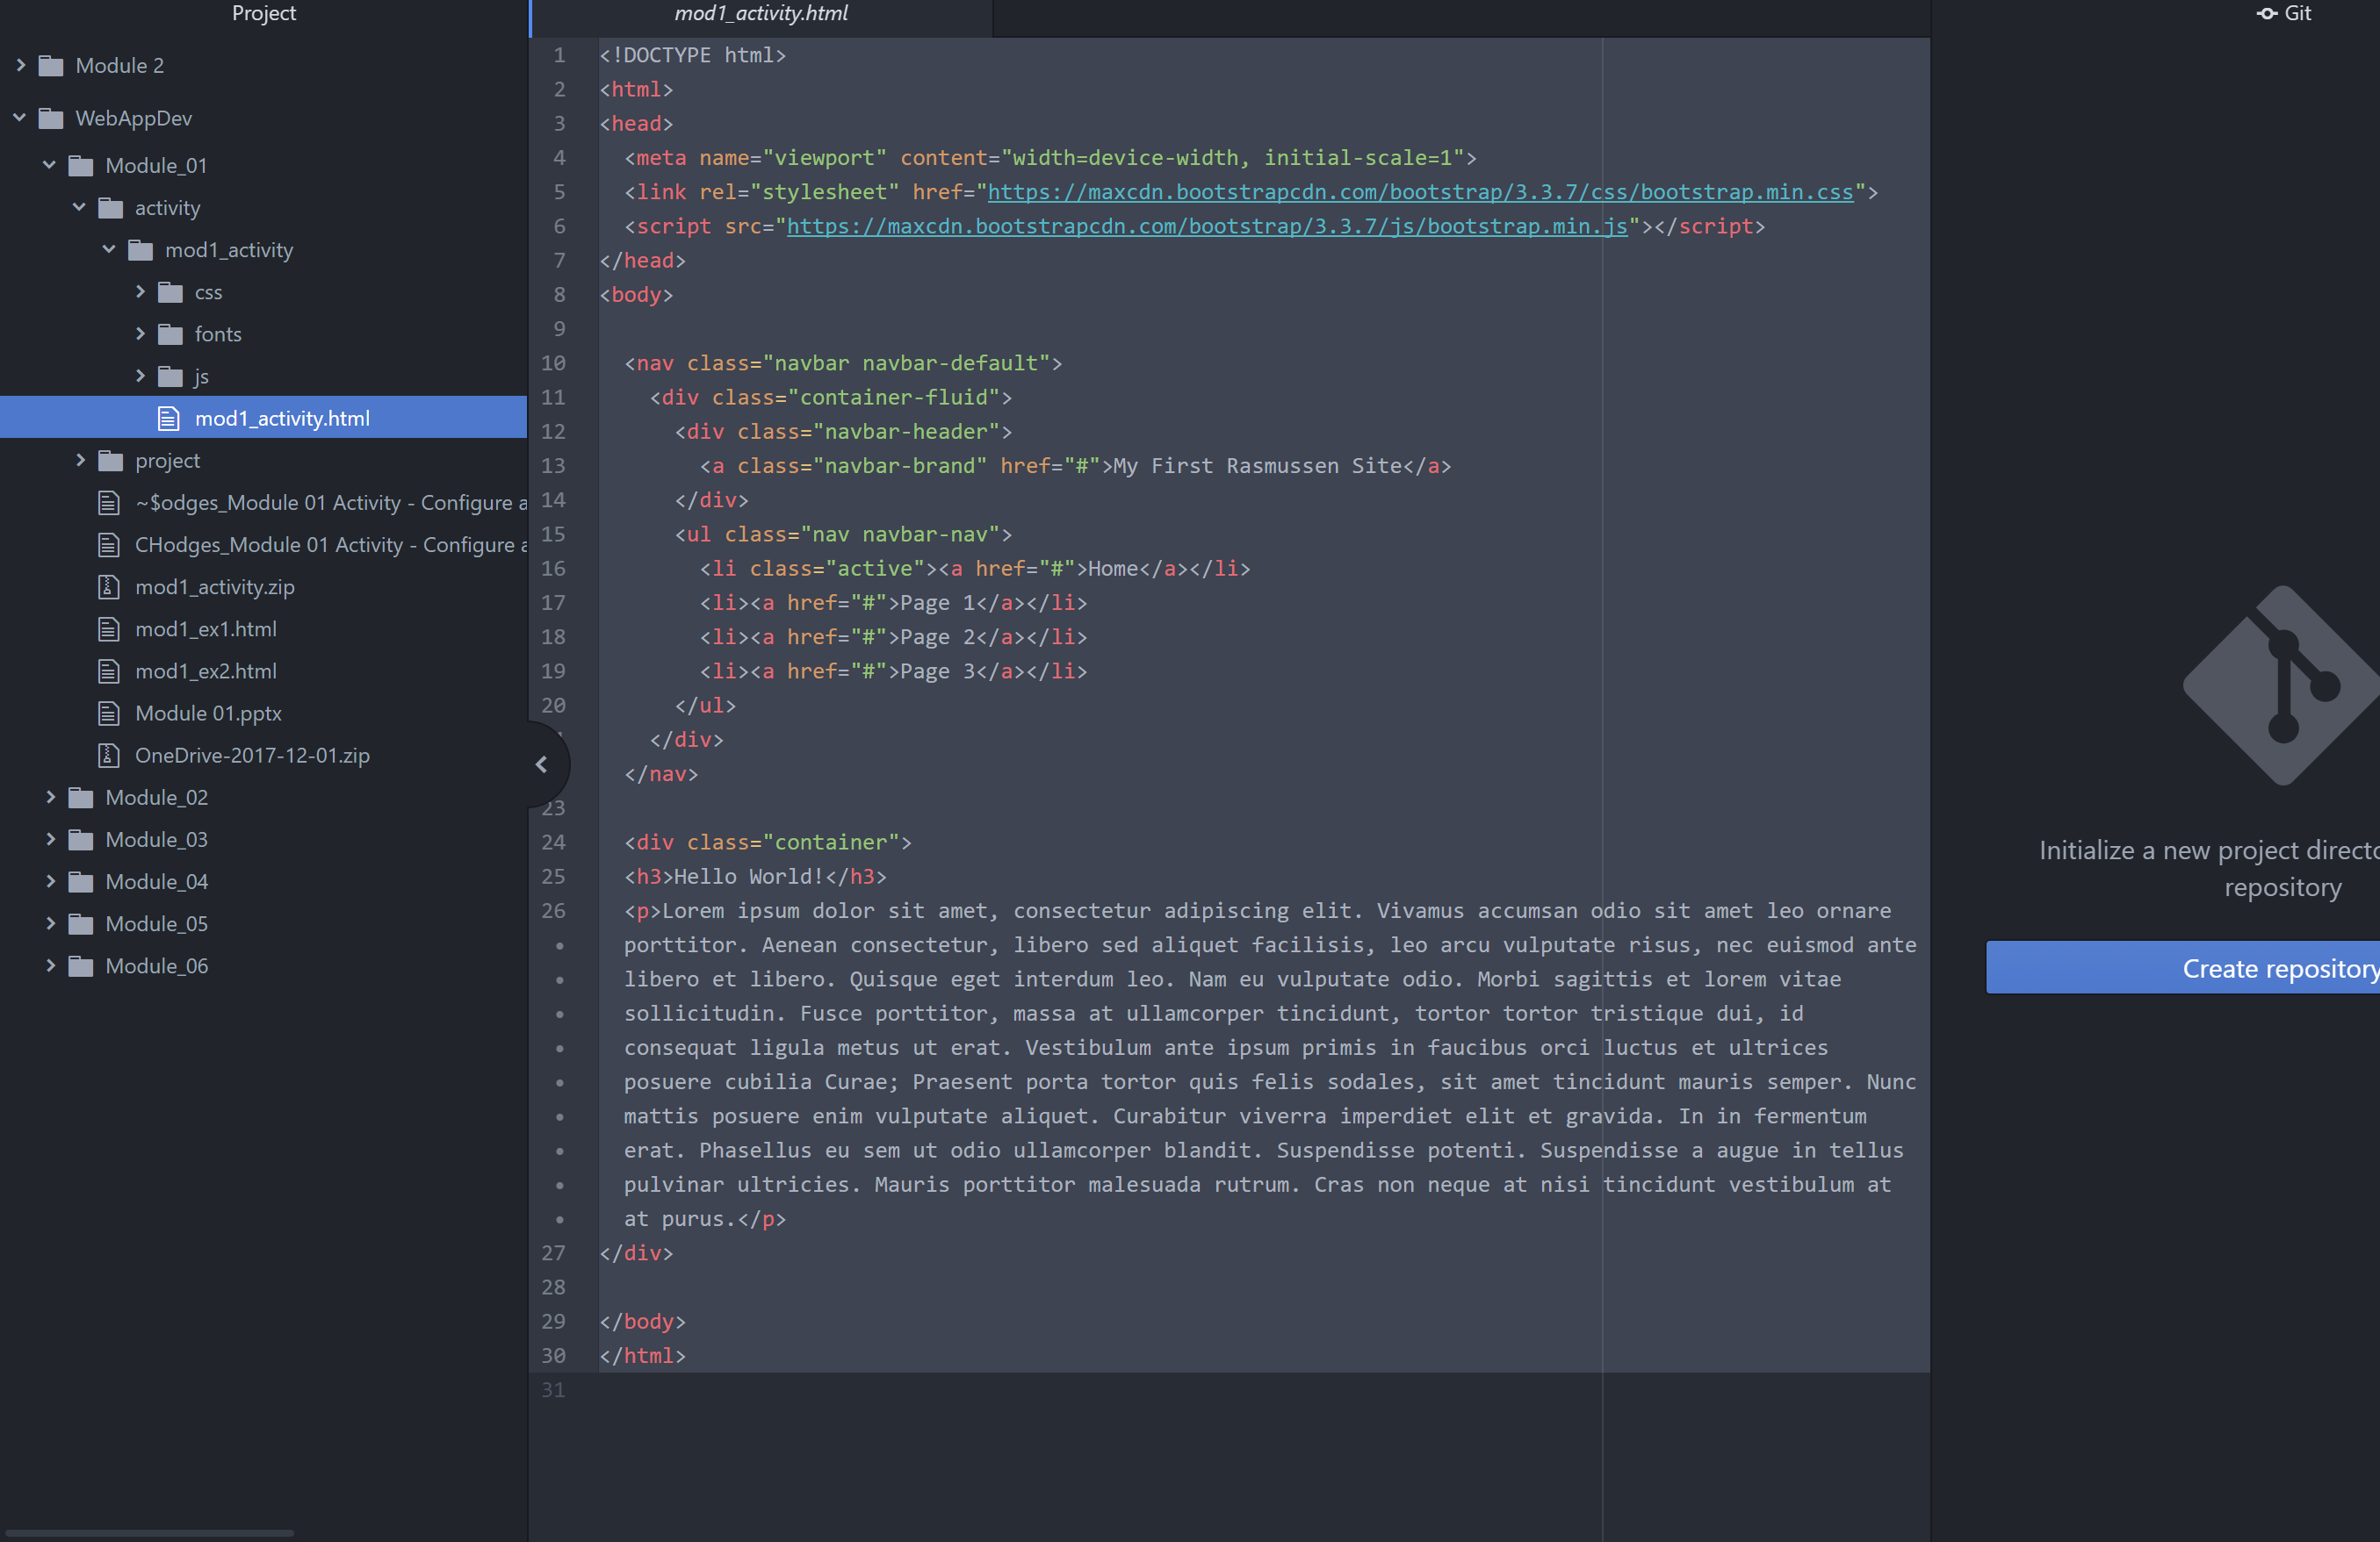

* + GitHub Desktop or Atom connected to git
  + 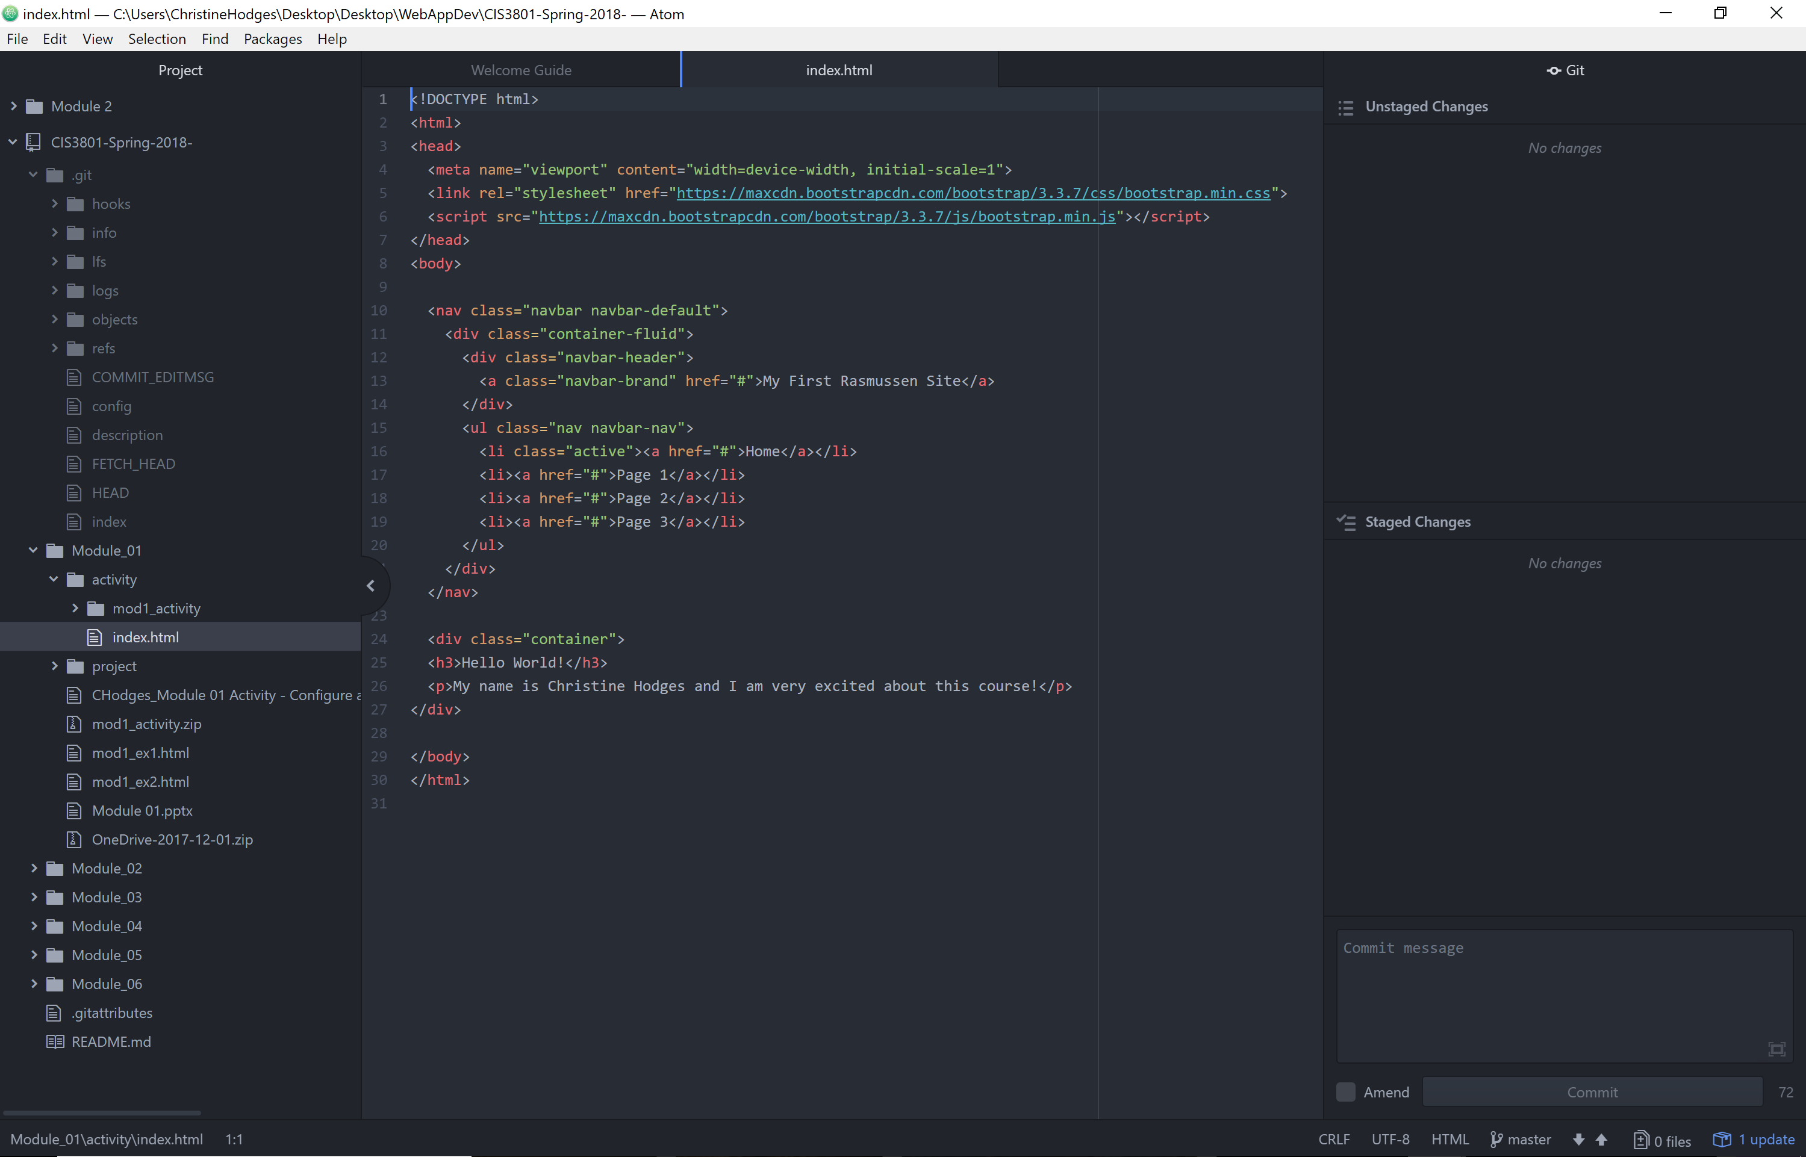
  + https://github.com/fitactivemomgineer/CIS3801-Spring-2018/settings/collaboration

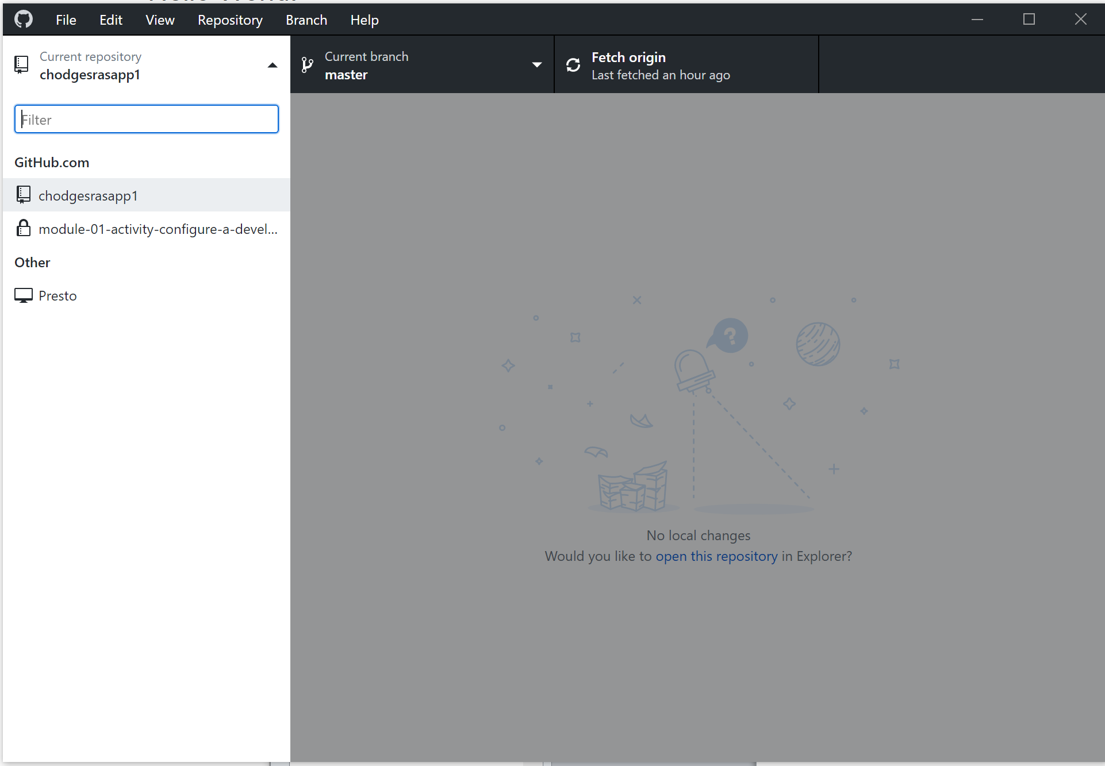

* + Hello World! Web page loaded in browser

Provided functioning LAMP VM URL to “Hello World” webage

<http://chodgesdns1.southcentralus.cloudapp.azure.com/Module_01/activity/mod1_activity/mod1_activity.html>

Created a single “Hello world” web page using Bootstrap front-end framework

